**Adding Services to Cloudera Manager**

**Login to Cloudera Manager**

* Login to Cloudera Manager using IP address and port 7180

Eg: <http://3.235.181.239:7180/>

* Now if you want to add host to the cluster. Go to

Hosts 🡪 All hosts

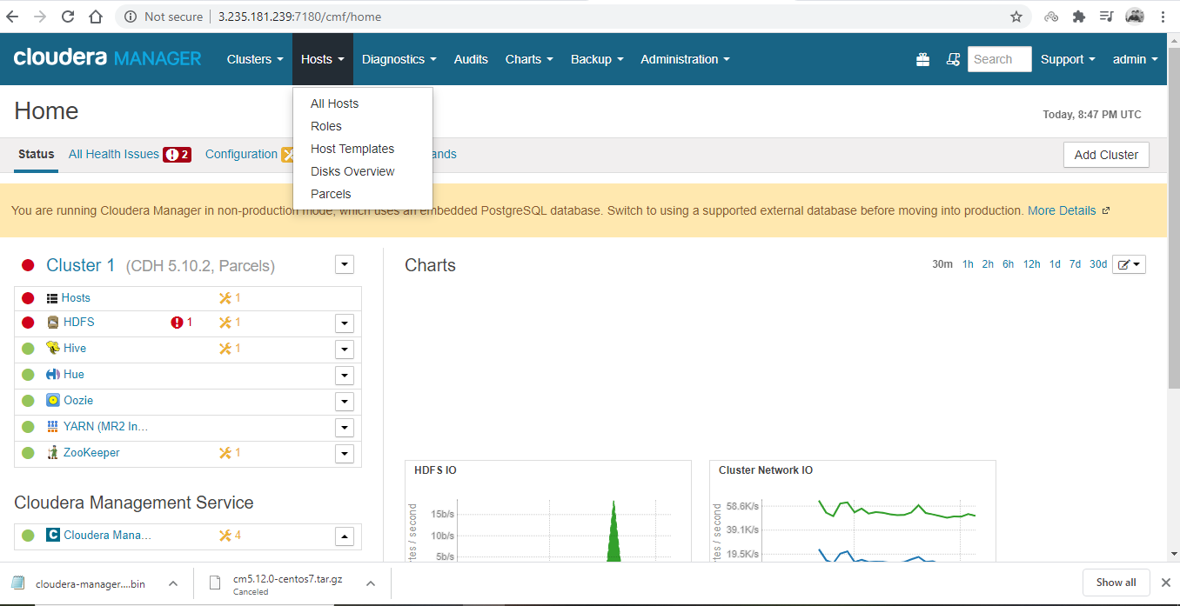

* Click on Add New Hosts to Cluster.

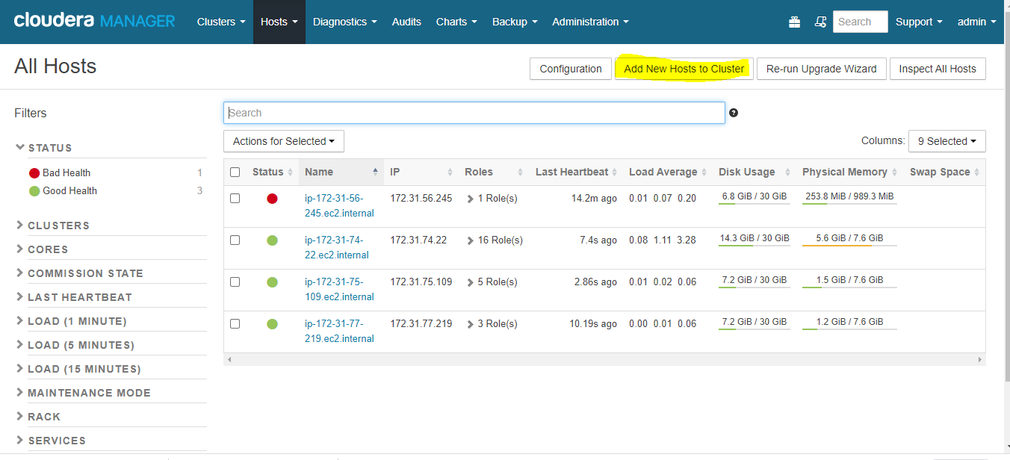

* Select Classic Wizard.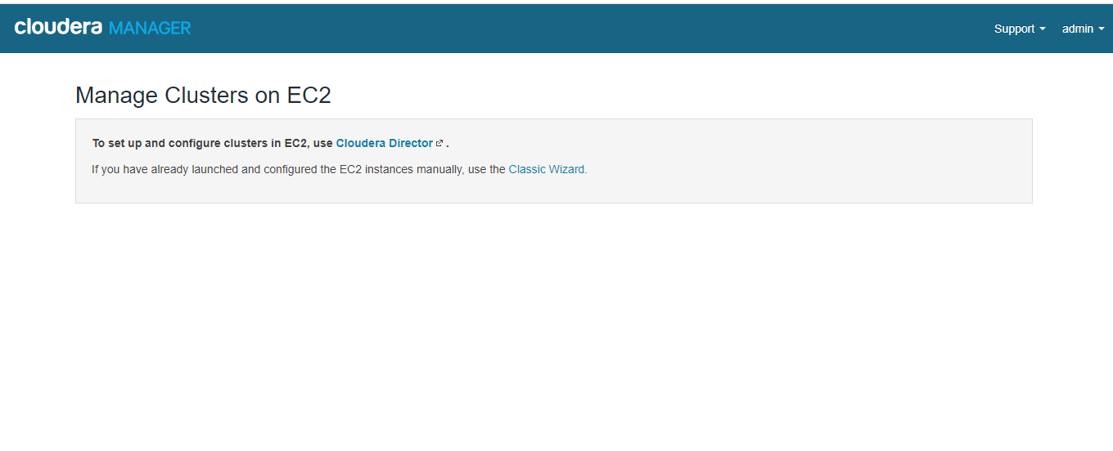
* Take the hostname of the machine and place the hostname in the box shown and press search as shown below:

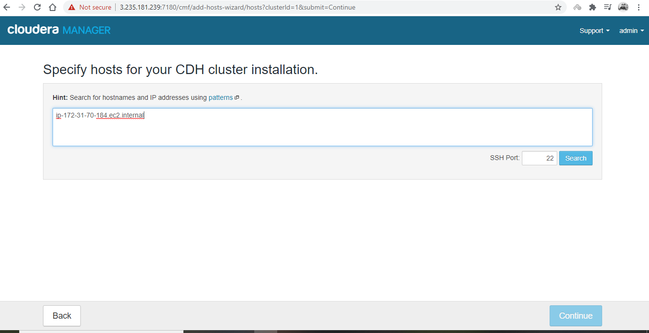

* It pings the new host where it is reachable or not. If it is reachable it shows tick mark else error pops on the console. Then press continue if everything is ok.

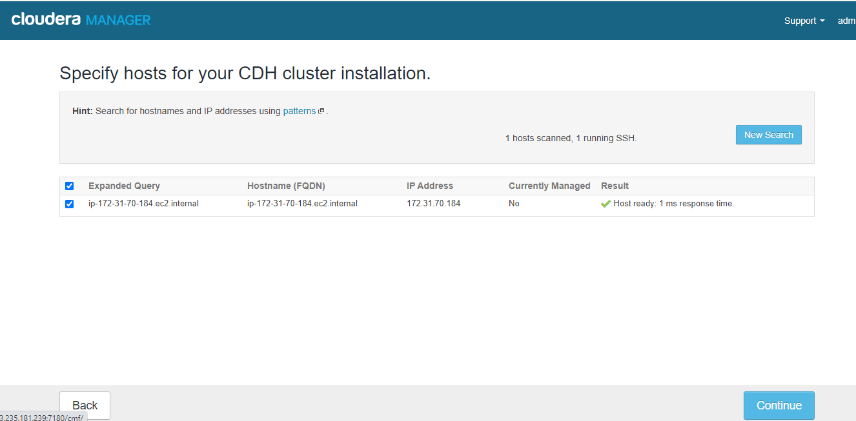

* If you are using internet-based repository select matched release (default). If you are using your own custom yum based repository the provide the repository link and custom GPG url key shown below:
* 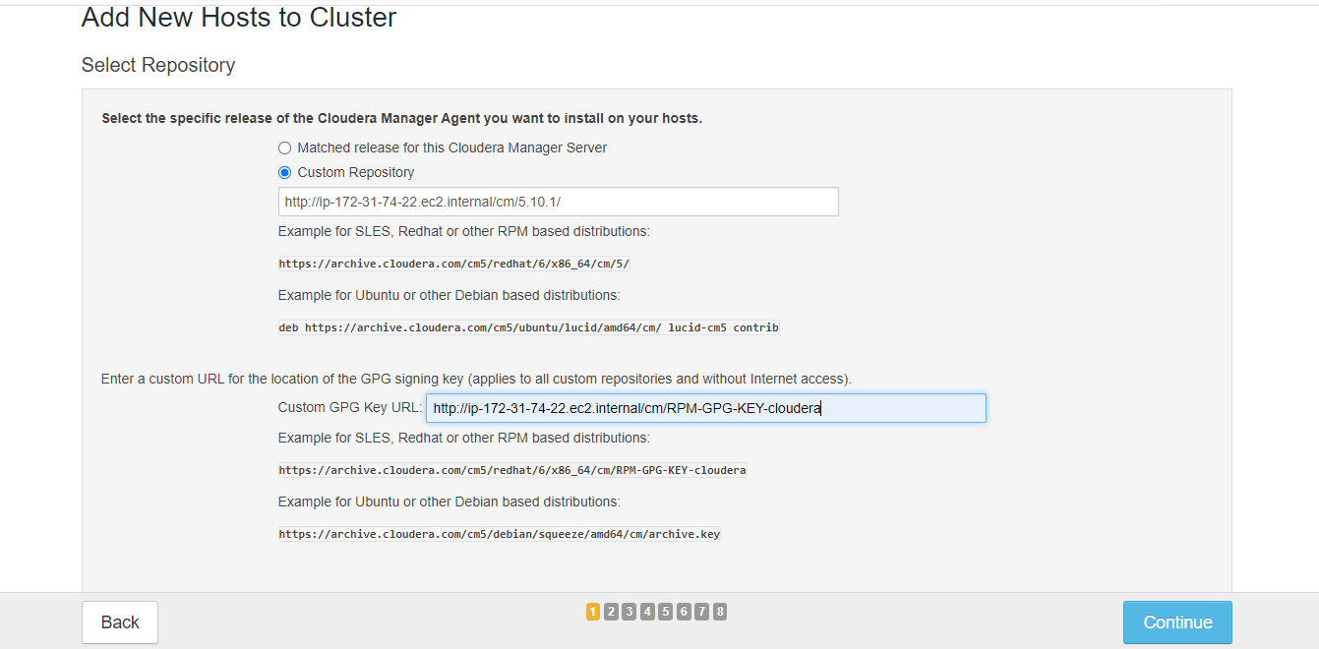
* Accept to install Oracle Java SE Development Kit (JDK) and Java Unlimited Strength Encryption Policy Files on the newly added host. Press continues.
* Provide the password of the machine and press continue.

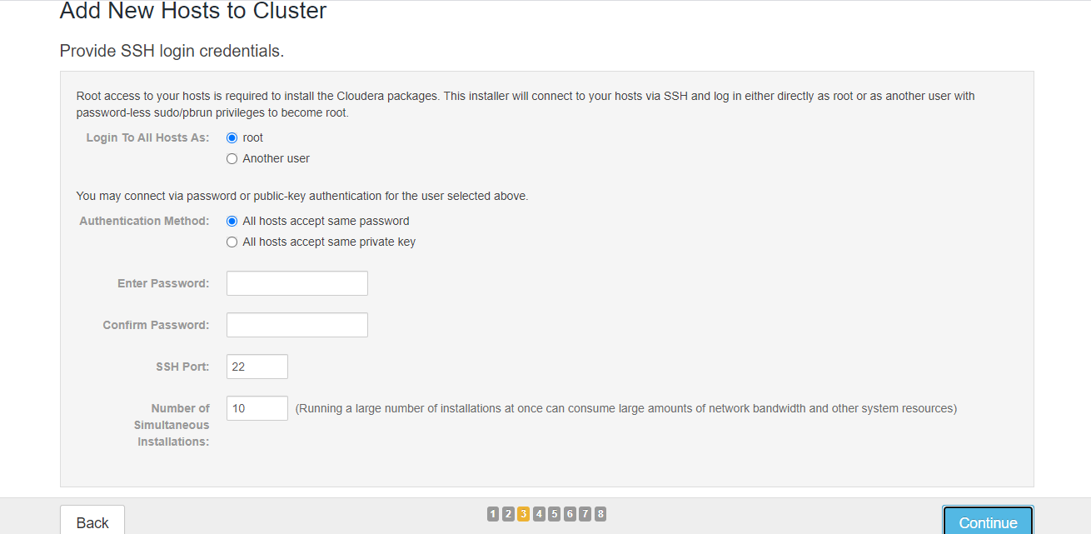

* Then Cloudera wizard will install Cloudera manager daemons, agent and required files. Then press continue after installation.

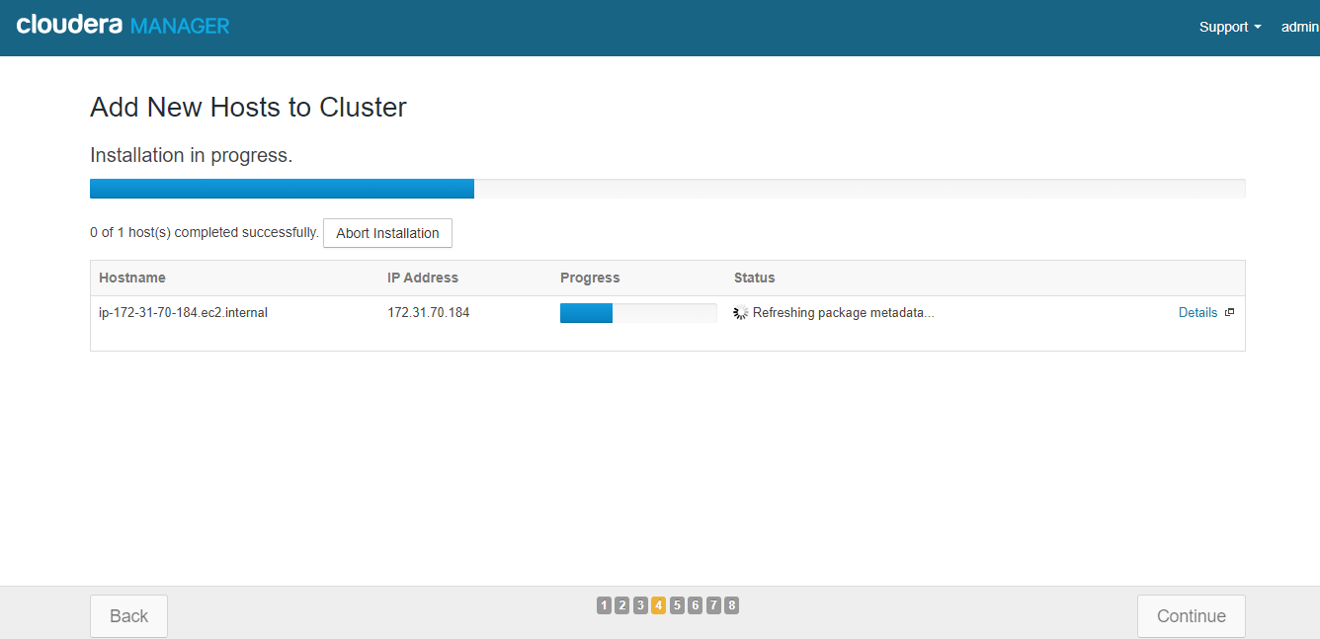

* Parcels will be installed on the new host by Cloudera Manager.

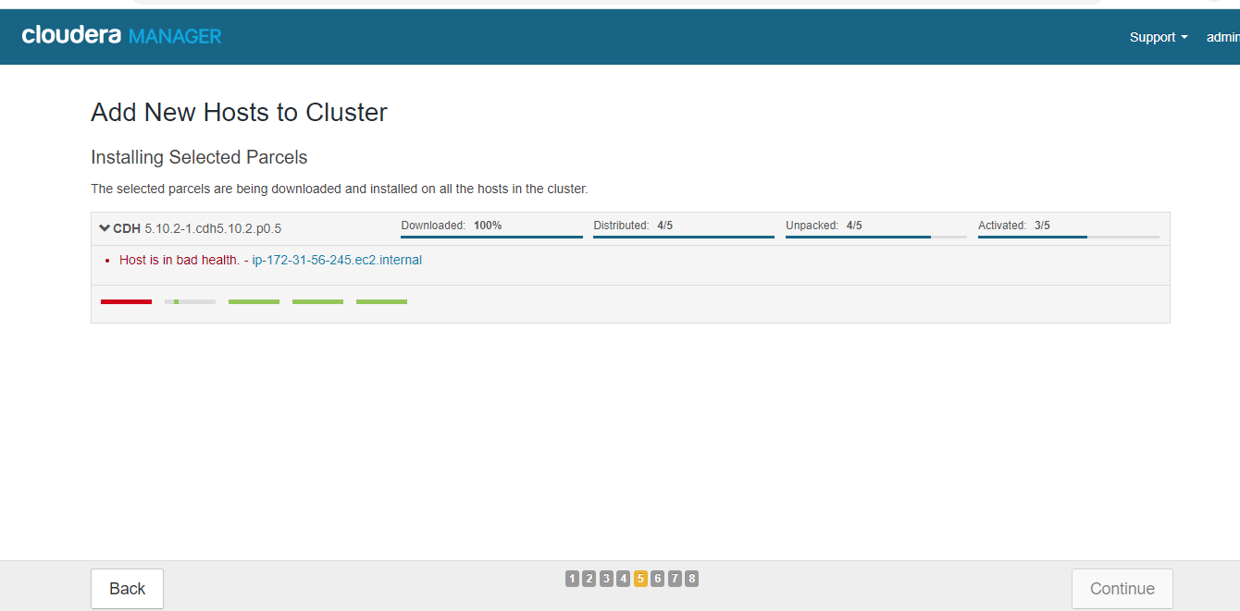

* Select None for host template.

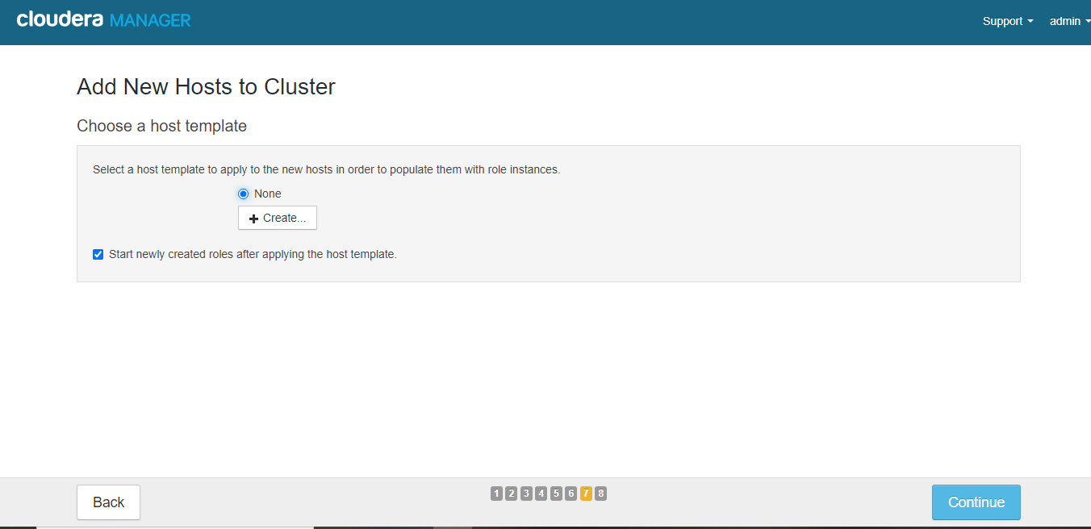

* In the next step deploy client configurations gets executed on the host.

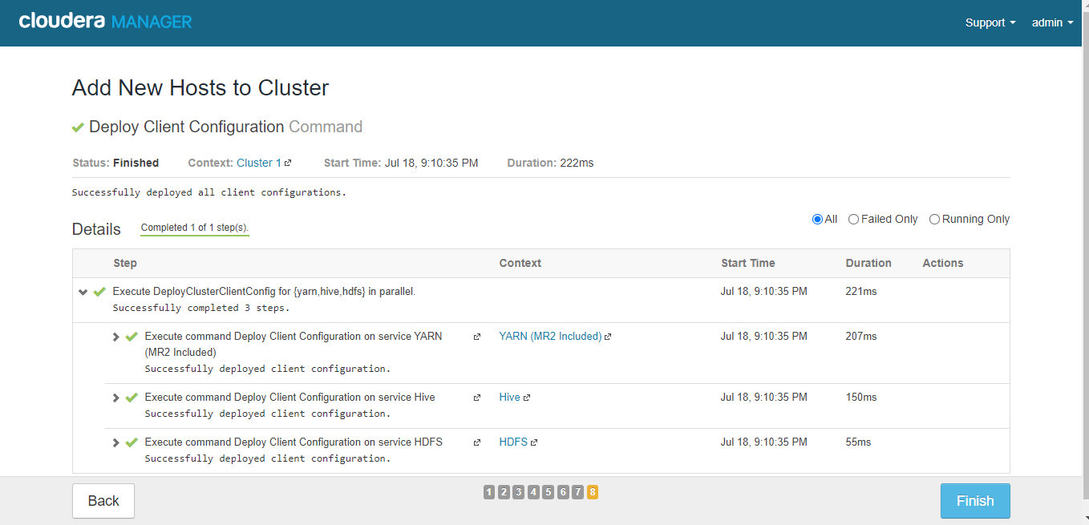

* You can see the newly added host in the Cloudera Manager cluster.

